**CAP 492**

**Homework**

**Problem Analysis and Formulation**

**Analyze the following problems and select the suitable technique or strategy to solve them. Propose an appropriate formulation according to the selected technique.**

1. SAAD Chemicals, Inc., produces two types of photo developing fluids. The first, a black-and-white picture chemical costs SAAD $2,500 per ton produce. The second, a color photo chemical, costs $3,000 per ton. Based on an analysis of current inventory levels and outstanding orders, SAAD’s production manager has specified that at least 30 tons of the black-and-white chemical and at least 20 tons of the color chemical must be produced during the next month. In addition, the manager notes that an existing inventory of a highly perishable raw material needed in both chemicals must be used within 30 days. To avoid wasting the expensive raw material, SAAD must produce a total of at least 60 tons of the photo chemicals in the next month. How can SAAD Inc. can achieve that with a lowest cost.
2. The Hanoi Towers game consists of 3 towers and n disks that are initially stacked on the 1st tower and must be re-stacked on the 3rd; the player can move one disk at a time from a tower i to a tower j but he is not allowed to put a bigger disk on top of a smaller one. Consider this problem with n = 3 as shown below:

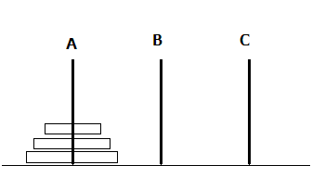

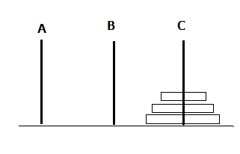

Initial State Goal State